MEHRAN UNIVERSITY

OF ENGINEERING & TECHNOLOGY

JAMSHORO, PAKISTAN

Subject: Software Construction and Development

(Lab 2 - Tasks Solution)

|  |  |
| --- | --- |
| **Roll No:** | **22SW028** |
| **Section:** | **I** |
| **Name** | **Arbab Hussain** |

**LAB 02 TASKS (USE CASE DIAGRAMS)**

**NOTE: THE DIAGRAMS ARE CREATED WITH A WEB APP NAMED LUCIDCHART**

**Scenario 1: Railway Reservation System**

Key functions include Search Trains, Book Tickets, Cancel Tickets, Register User, Login, and Generate Reports. Passengers can search for trains, book and cancel tickets, and manage their user accounts. Administrators handle user registrations, generate reports, and oversee system operations, ensuring efficient and effective management of the railway reservation process.

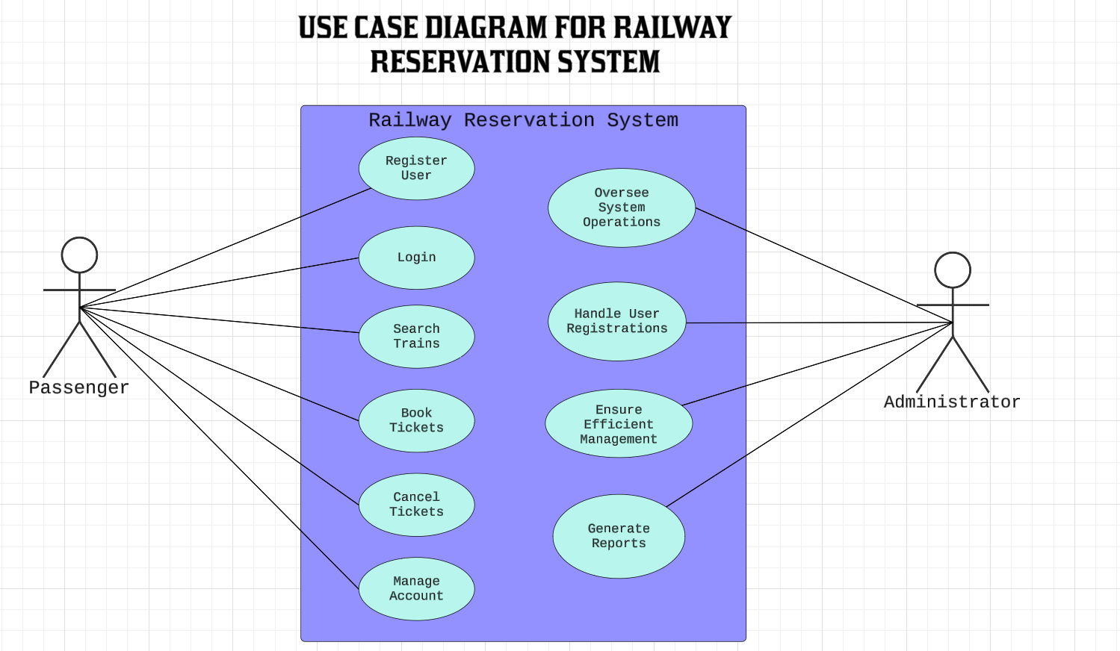

**Scenario 2: Student Management System**

The system should handle the registration and management of students, courses, and grades. Students can enroll in courses, view their schedules, and check their grades. Professors can create courses, assign grades, and update course content. The administrator will oversee the entire system, managing users, courses, and schedules.

